# [DEVELOP THE PYTHON SCRIPT](https://careereducation.smartinternz.com/Student/guided_project_workspace/20178" \l "collapse3)

**Publish data to the IBM Cloud**

Team ID : PNT2022TMID23663

**Project Title : SIGNS WITH SMART CONNECTIVITY FOR BETTER ROAD SAFETY**

**TO Make a publisher and subscriber in the process of python and IBM cloud**

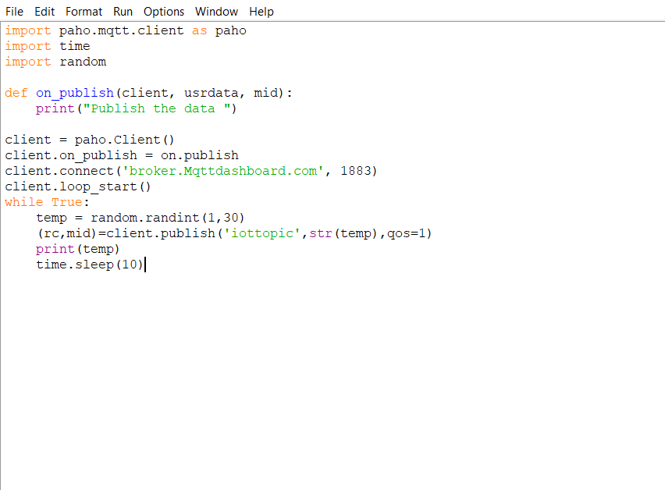

Output:

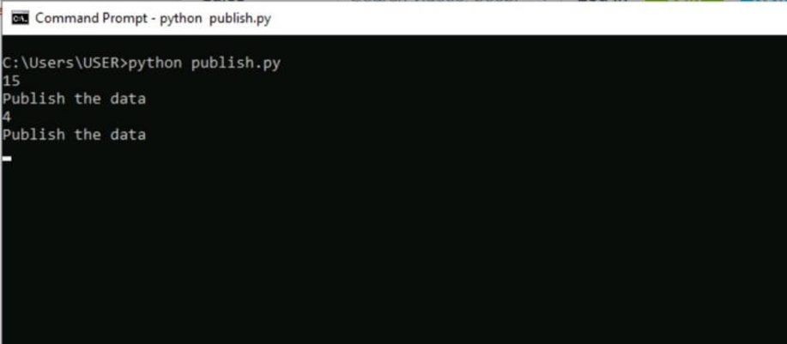

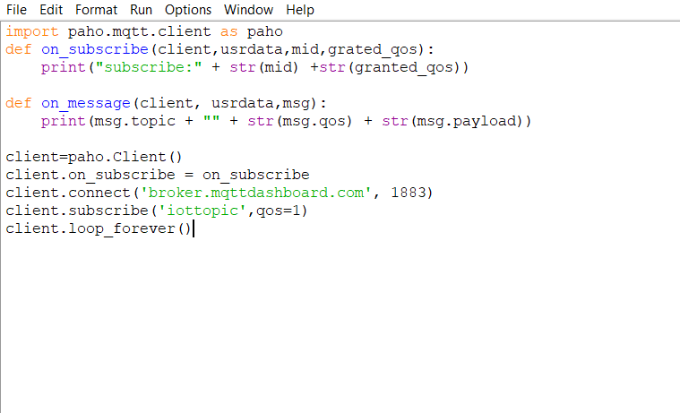

Output:

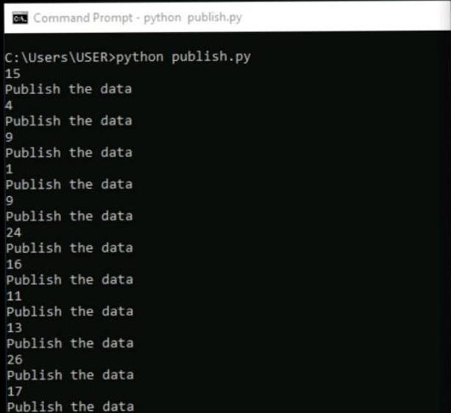

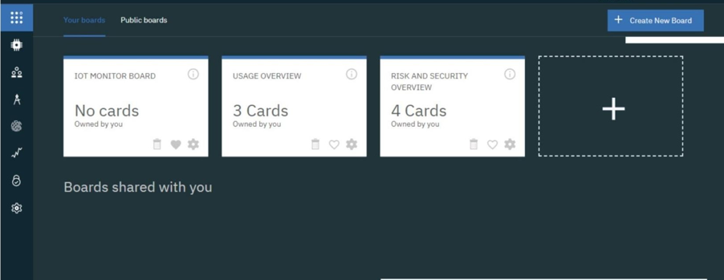

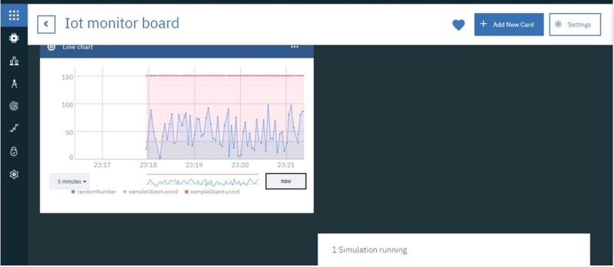

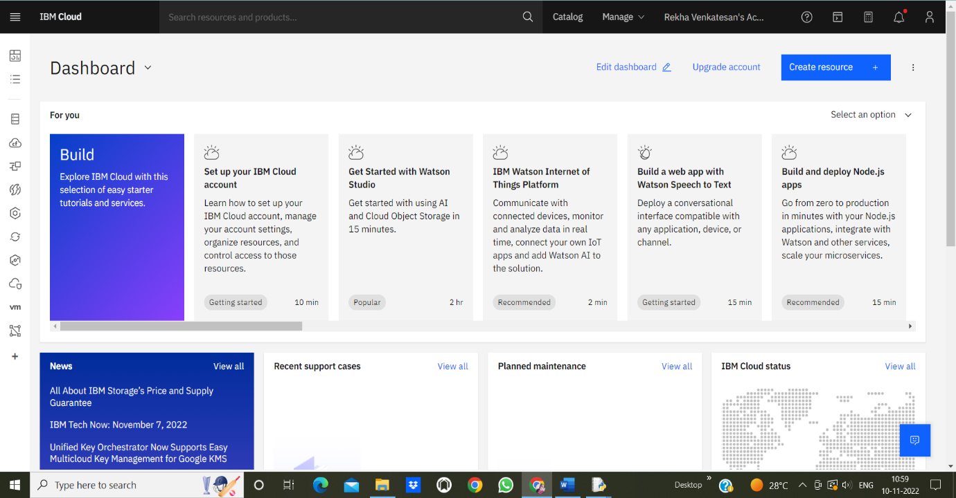

# PROGRAM

|  |
| --- |
| #IBM  Watson IOT  Platform |
| #pip install wiotp-sdk |
| import wiotp.sdk.device |
| import time |
| import random |
| myConfig = { |
| "identity": { |
| "orgId": "hj5fmy", |
| "typeId": "NodeMCU", |
| "deviceId":"12345" |
| }, |
| "auth": { |
| "token": "12345678" |
| } |
| } |

|  |
| --- |
| def myCommandCallback(cmd): |
| print("Message received from IBM IoT Platform: %s" % cmd.data['command']) |
| m=cmd.data['command'] |
| client = wiotp.sdk.device.DeviceClient(config=myConfig, logHandlers=None) |
| client.connect() |
| while True: |
| temp=random.randint(-20,125) |
| hum=random.randint(0,100) |
| myData={'temperature':temp, 'humidity':hum} |
| client.publishEvent(eventId="status", msgFormat="json", data=myData, qos=0, onPublish=None) |
| print("Published data Successfully: %s", myData) |
| client.commandCallback = myCommandCallback |
| time.sleep(2) |
| client.disconnect() |